Membrane Worksheet

Part I. Membrane Structure
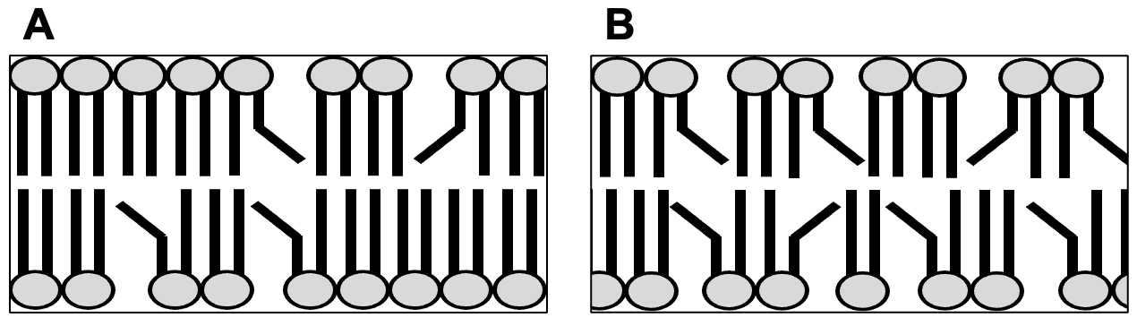
1. a. Figures A and B, above, illustrate portions of two different phospholipid bilayers. Which one would you expect to be more viscous (A or B)? Briefly explain how you know.

b. What would happen to the fluidity of membrane A if the cell added cholesterol?

c. What would happen to the fluidity of membrane B if the cell added cholesterol?

2. The figure below illustrates a cell membrane with four associated proteins (A-D). For each protein, indicate if it is an integral or peripheral protein. Briefly explain how you know?

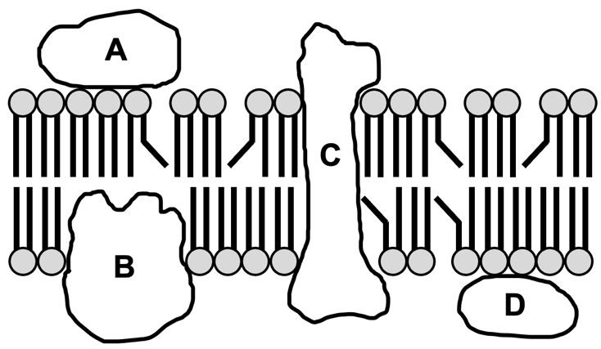

Part II. Selective Permeability of Membranes - Diffusion and Osmosis
3. Selectively permeable membranes let some solutes diffuse but not others. Given a problem where two different solutions are separated by a selectively permeable membrane, you are expected to predict what will happen next. Solving these problems will always involve the same set of steps
1. Determine which solutes will diffuse and which solutes will NOT diffuse.
2. For each solute that will diffuse, calculate the equilibrium concentration on each side.
3. Add up the total solutes on each side to determine if equilibrium solutions are isotonic or if not label each side as hypertonic or hypotonic.

a. Problem: "In an experiment, an artificial membrane that is permeable to ions but not larger molecules like sugars separates two solutions: 20 mM NaCl, and water. Determine if there will be osmosis, and if so draw an arrow showing the net flow of water."

Process: You know NaCl will dissolve in water to give Na+ and Cl- ions; there is 20 mM NaCl, so there will be 20 mM Na+ and 20 mM Cl-. These are the "initial conditions" (A, below).
The problem tells you that ions will diffuse through the membrane, so you need to "do diffusion!" Calculate the equilibrium concentrations of each solute: in this problem 20 + 0 /2 = 10 mM on each side for both Na+ and Cl-. These are the "equilibrium concentrations" (B, below)
Will there be osmosis? Osmosis will occur if there is a difference in the total amount of solutes: in this case there is 10 mM Na+ plus 10 mM Cl- = 20 mM total on each side - they are the same! Go ahead an label each side isotonic and write "no osmosis" under Figure B. You do not need to draw an arrow.

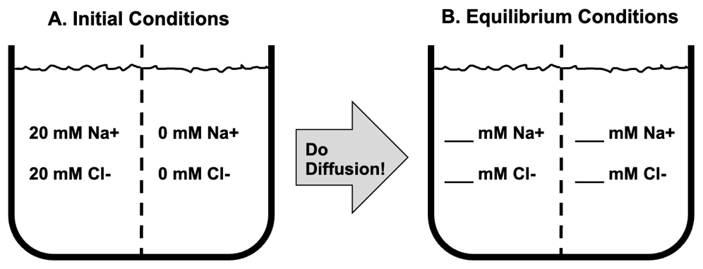

b. Now you try! Problem: "In an experiment, an artificial membrane that is permeable to ions but not larger molecules like sugars separates two solutions: 5 mM Ca++ with 5 mM lactose, and water. Determine if there will be osmosis, and if so draw an arrow showing the net flow of water."
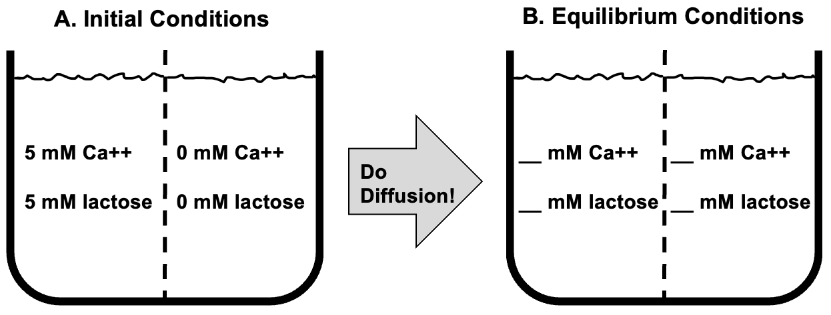

Process: This one is a bit different! When you "do diffusion" only Ca++ goes to equilibrium, with 2.5 mM on each side. Lactose is a sugar, so it will not diffuse, and stays 5 mM and 0 mM at equilibrium. That means there is more total solute on the left (7.5 mM vs 2.5 mM), so the left is hypertonic. There will be osmosis with a net movement of water to the left (towards hypertonic).

Part III. Diffusion and Osmosis Practice Problems
4. For each set of initial conditions below determine if osmosis will occur, and draw an arrow showing the net flow of water as needed. Assume the artificial membrane separating the two solutions will allow ions to diffuse but not sugars. Be sure to give equilibrium concentrations for all solutes and label isotonic, hypertonic, or hypotonic as appropriate.

